# Earth Temperature Data

|  |  |  |  |  |  |
| --- | --- | --- | --- | --- | --- |
| City | Latitude | January Ave. Temp. (oF) | July Ave.  Temp. (oF) | January Ave. Daylight (Hours) | July Ave. Daylight (Hours) |
| Fairbanks, AK | 64.8 N | -2.0 | 72.0 | 3.7 | 21.8 |
| Minneapolis, MN | 45.0 N | 22.0 | 83.0 | 9.0 | 15.7 |
| Las Cruces, NM | 32.5 N | 57.0 | 96.0 | 10.1 | 14.2 |
| Honolulu, HI | 21.3 N | 80.0 | 88.0 | 11.3 | 13.6 |
| Quito, Ecuador | 0 | 77.0 | 77.0 | 12.0 | 12.0 |
| Apia, Samoa | 13.8 S | 80.0 | 78.0 | 11.1 | 12.7 |
| Sydney, Australia | 33.9 S | 78.0 | 61.0 | 14.3 | 10.3 |
| Ushuaia, Argentina | 54.6 S | 57.0 | 39.0 | 17.3 | 7.4 |

1. If the Seasons were caused by the distance between the Earth and the Sun, would you expect both hemispheres to experience the same season at the same time? Explain your answer.
2. When is it coldest in the Southern Hemisphere?
3. When is it coldest in the Northern Hemisphere?
4. When is it hottest in the Southern Hemisphere?
5. When is it hottest in the Northern Hemisphere?
6. How, if at all, does the average amount of daylight (Average Daylight Hours) relate to the average temperatures?
7. Does Australia and Minnesota experience the same seasons at the same time? Explain your answer.

# Perihelion and Aphelion

1. If the distance to the Sun was the key cause of the Earth’s seasons, which Season in Minnesota would you expect to align with which distance?
   1. Aphelion:
      1. Autumn
      2. Winter
      3. Spring
      4. Summer
   2. Parihelion:
      1. Autumn
      2. Winter
      3. Spring
      4. Summer
2. Using the Solar Distance table, when is the Earth closest to the Sun?
3. Using the Solar Distance table, when is the Earth farthest from the Sun?
4. What season is it in Minnesota when the Earth is closest to the Sun?
5. What is the percent difference in the aphelion and perihelion distance in 2023?
   1. First, what is the average distance (in miles)?

average distance = (aphelion + perihelion) / 2

* 1. The percent difference is (aphelion - perihelion) / average distance:

1. Do you think that percent difference is enough to cause the seasonal changes? Explain your answer.

Solar Distance Table

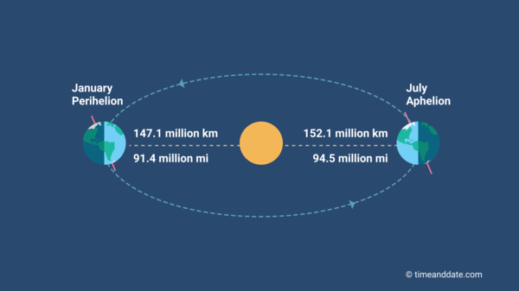

| **Year** | **Perihelion** | **Distance** | **Aphelion** | **Distance** |
| --- | --- | --- | --- | --- |
| **2023** | January 4, 2023 10:17 am | 91,403,034 mi | July 6, 2023 3:06 pm | 94,506,364 mi |
| **2024** | January 2, 2024 6:38 pm | 91,404,095 mi | July 5, 2024 12:06 am | 94,510,539 mi |
| **2025** | January 4, 2025 7:28 am | 91,405,993 mi | July 3, 2025 2:54 pm | 94,502,939 mi |
| **2026** | January 3, 2026 11:15 am | 91,403,637 mi | July 6, 2026 12:30 pm | 94,502,962 mi |
| **2027** | January 2, 2027 8:32 pm | 91,406,556 mi | July 5, 2027 12:05 am | 94,510,857 mi |
| * All aphelion/perihelion times are in local Minneapolis time. | | | | |

# Images of the Sun at perihelion and aphelion

1. Explain why the Sun appears to have two different sizes?
2. Which image is aphelion, which is perihelion?
3. Using a ruler, what is the length of the larger image of the Sun?
4. Using a ruler, what is the length of the smaller image of the Sun?
5. What is the ratio of the two diameters?
6. Do you think the change in our distance to the Sun is enough to cause seasonal changes?

# Images of the Sun at perihelion and aphelion

